**Enterprise Resource Planning**

**Training User Manual**

**VERSION 12.0.0**

**Buttons Functionality**

|  |  |
| --- | --- |
|  | **Add** = to create of new record |
|  | **Update** = to modify any existing record |
|  | **Delete** = to remove any record |
|  | **Show** = to see the specified record showing its ID/Code |
|  | **Clear =** to make blank the fields of the form. |
|  | **First** = to see the top record |
|  | **Next** = to see the next record |
|  | **Prev** = to see the previous record |
|  | **Last** = to see the bottom record |

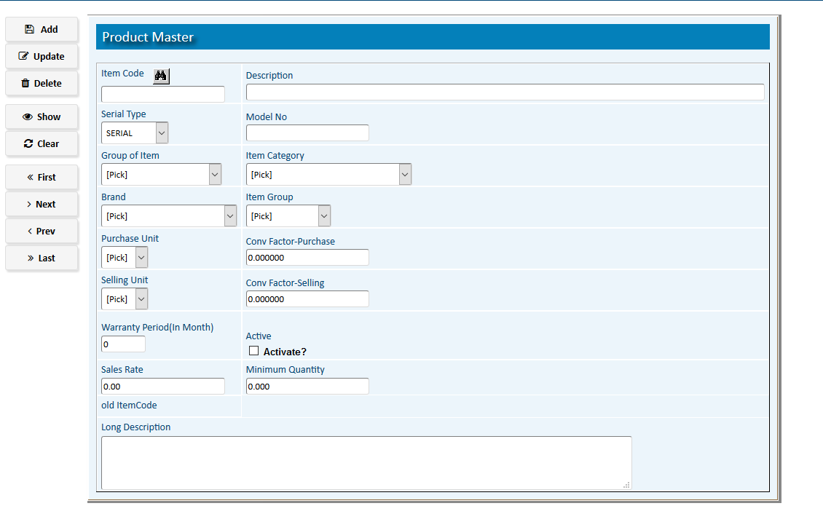

1. **Add**

**Step 1** Open the Screen

**Step 2** Fill up the fields without Code/ID field. Code/ID will be created automatically after pressing **Add** Button

**Step 3** Select the expected option (such as group, category) from the drop-down pop-up menu list.

**Step 4**  Pick & select the expected value from the lists adjusted within the fields.

**Step 5** Check tick mark on the Active Check box.

**Step 6** Press **Add** Button.

**Step 7 Confirm** the record by pressing **Confirm** if required. The record will be disabled to **Delete** & **Update** after confirmation**.**

**Result:** A new record will be created.

|  |  |
| --- | --- |
| **Step 1** | Open System **>** Menu **>**The Screen |
| **Step 2** | Select *Code* from side list or write the Code in the *Code* field |
| **Step 3** | Click **show** |
|  | Requested Data checked for availability and will show in the form. |
| **Step 4** | Modify data in the form as required. |
| **Step 5** | Click **Update** |
| **Result:** | Requested Data in the form will be updated as modified. |

1. **Update**

|  |  |
| --- | --- |
| **Step 1** | Open System **>** Menu **>**The Screen |
| **Step 2** | Select *Code* from side list or write the Code in the *Code* field |
| **Step 3** | Click **show** |
|  | Requested Data checked for availability and will show in the form. |
| **Step 5** | Click **Delete** & then **Ok** on confirmation Dialog box. |
| **Result:** | Requested Record in the form will be Deleted. |

1. **Delete**

|  |  |
| --- | --- |
| **Step 1** | Open System **>** Menu **>**The Screen |
| **Step 2** | Select *Code* from side list or write the Code in the *Code* field |
| **Step 3** | Click show |
| **Result** | Requested record checked for availability and will be show within details. |

1. **Show**

|  |  |
| --- | --- |
| **Step 1** | To make Blank All the fields of the form-- |
| **Step 3** | Click **Clear** |
| **Result** | Data from all the fields will remove & the form will be Blank. |

1. **Clear**

|  |  |
| --- | --- |
| **Step 1** | Open System **>** Menu **>**The Screen |
| **Step 3** | Click **First** |
| **Result:** | The First Record of the list will be shown within Details. |

1. **First**

|  |  |
| --- | --- |
| **Step 1** | Open System **>** Menu **>**The Screen |
| **Step 2** | Click **Show** to see any record or click **First/Last** to see the first/last record. |
| **Step 3** | Click **Next** |
| **Result:** | The Next Record of the list will be shown within Details. | |

1. **Next**

|  |  |
| --- | --- |
| **Step 1** | Open System **>** Menu **>**The Screen |
| **Step 2** | Click **Show** to see any record or click **First/Last** to see the first/last record. |
| **Step 3** | Click **Prev** |
| **Result:** | The previous Record of the list will be shown within Details. | |

1. **Prev**

|  |  |
| --- | --- |
| **Step 1** | Open System **>** Menu **>**The Screen |
| **Step 3** | Click **Last** |
| **Result:** | The Last Record of the list will be shown within Details. | |

1. **Last**

**On several forms there are extra special buttons:**

Such as:

**Print**

**Confirm, Details**

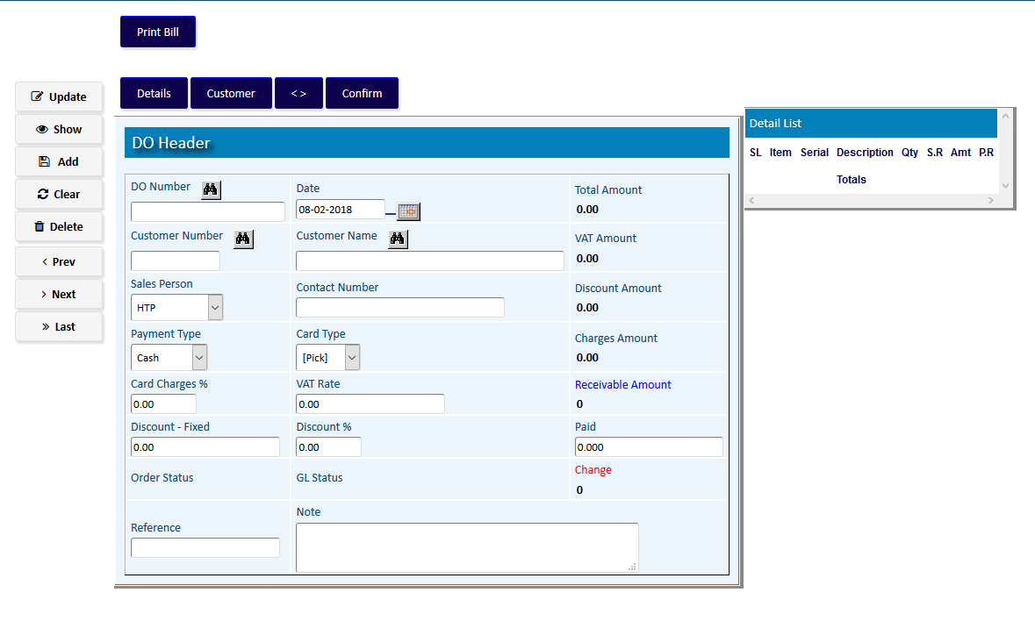

**Details :** To add the **Details** of any entry.

**Confirm :** To make confirmed any entry. After confirmation, the record won’t be able to **Update /Delete.**

**Print :** To **Print** the report within details of any entry**.**